**––**

**Artificial Intelligence Externship**

A REPORT

submitted by

**Rahul Sandireddy (20BCE1001)**

*in partial fulfilment for the award*

of

**B. Tech. Computer Science and Engineering**

**School of Computer Science and Engineering**



**July 2023**



**School of Computer Science and Engineering**

**DECLARATION**

I hereby declare that the project entitled **“Artificial Intelligence Externship”** submitted by me to the School of Computer Science and Engineering, Vellore Institute of Technology, Chennai Campus, Chennai 600127 in partial fulfilment of the requirements for the award of the degree of **Bachelor of Technology – Computer Science and Engineering** is a record of bonafide work carried out by me**.** I further declare that the work reported in this report has not been submitted and will not be submitted, either in part or in full, for the award of any other degree or diploma of this institute or of any other institute or university.



Signature

**Rahul Sandireddy (20BCE1001)**



**School of Computer Science and Engineering**

**CERTIFICATE**

The project report entitled “**Artificial Intelligence Externship**” is prepared and submitted by **Rahul Sandireddy (Register No: 20BCE1001)**.Ithas been found satisfactory in terms of scope, quality and presentation as partial fulfilment of the requirements for the award of the degree of **Bachelor of Technology – Computer Science and Engineering** in Vellore Institute of Technology, Chennai, India.

**Examined by**:

**Examiner I Examiner II**

**CERTIFICATE OF MERIT OBTAINED FROM THE INDUSTRY**

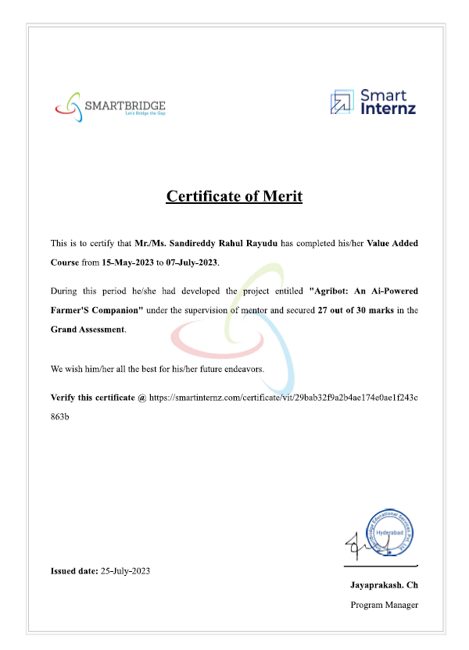

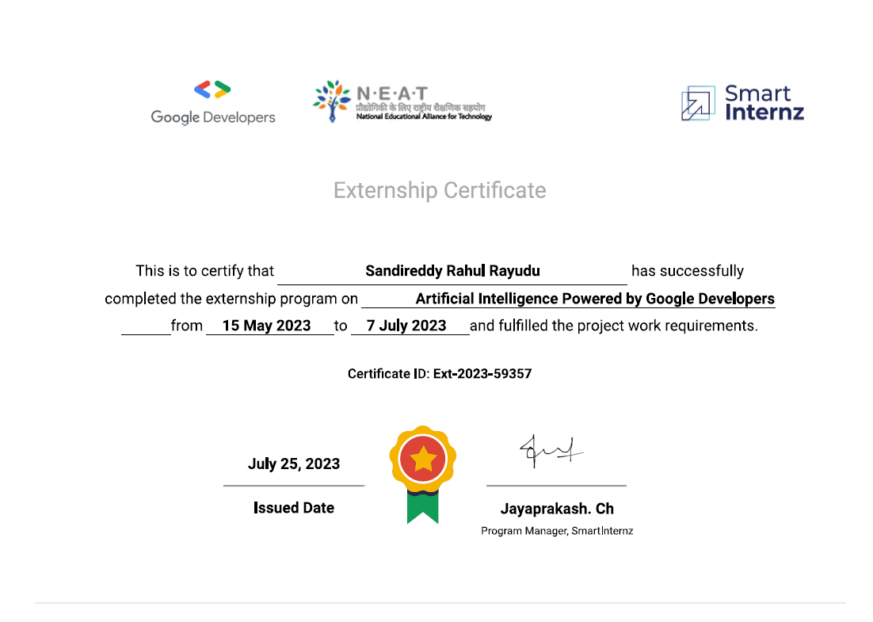



**ACKNOWLEDGEMENT**

First and foremost, I would like to express my profound gratitude to God, the Almighty, for bestowing His blessings upon our internship and the successful culmination of this research endeavor.

I extend my sincere appreciation to Dr. Nithyanandam P, Head of the Department (HoD) of B.Tech Computer Science and Engineering at VIT Chennai, for his invaluable supervision and unwavering support during the course of our research study.

I am deeply indebted to Dr. Ganesan R, Dean of the School of Computer Science & Engineering at VIT Chennai, and Dr. Parvathi R, Associate Dean (Academics) of the School of Computer Science & Engineering at VIT Chennai, for their boundless empathy, patience, and the wealth of knowledge they shared with us throughout this journey.

It was indeed a great privilege and honor to work under the guidance of Dr. Geetha S, Associate Dean (Research) of the School of Computer Science & Engineering at VIT Chennai. Her mentorship has been instrumental in shaping this research project.

Thank you to each and every individual and entity mentioned above for their invaluable contributions to this project.

**CONTENTS**

|  |  |  |  |
| --- | --- | --- | --- |
| **Chapter** | | **Title** | **Page** |
|  |  | |  |
|  | Title Page | | 01 |
|  | Declaration | | 02 |
|  | Certificate | | 03 |
|  | Industry certificate | | 04-05 |
|  | Acknowledgement | | 06 |
|  | Table of contents | | 07 |
|  | List of Figures | | 08 |
|  | List of Abbreviation | | 09 |
|  | Abstract | | 10 |
|  |  | |  |
| 1 | Introduction | | 11 |
| 2 | Theoretical Analysis | | 12-13 |
| 3 | Experimental Investigation | | 14-15 |
| 4 | Observations | | 16-17 |
| 5 | Application and drawbacks | | 17-19 |
| 6 | Conclusion | | 19 |
| 7 | Future Scope | | 19-20 |
| 8 | References | | 20 |
| 9 | Appendix – I (Google cloud) | | 20-25 |
|  |  | |  |

**LIST OF FIGURES**

|  |  |
| --- | --- |
| **Title** | **Page** |
| Fig 1: Block Diagram | 13 |
| Fig 2: Chatbot Model metrics | 16 |
| Fig 3: Image classification model metrics | 17 |
| Fig 4: Interface | 20-22 |
| Fig 5: Google cloud | 23-25 |

**LIST OF ABBREVIATIONS**

|  |  |
| --- | --- |
| **Abbreviation** | **Expansion** |
| **CNN** | **Convolutional Neural Networks** |
| **RNN** | **Recurrent Neural Network** |
|  |  |

**ABSTRACT**

The agricultural sector is a cornerstone of global food security and economic stability. Yet, in today's landscape, farmers often face a critical challenge in accessing essential information and expert guidance. This scarcity of knowledge can result in obstacles related to crop management, pest control, and overall agricultural productivity. To address these challenges, this paper introduces a comprehensive project that harnesses the power of artificial intelligence (AI) and machine learning to empower farmers. The project centers around an innovative AI chatbot, seamlessly integrated with a crop disease classification system, poised to revolutionize the way farmers acquire information and support. Within the contemporary agricultural context, farmers grapple with limited access to vital information encompassing crop cultivation techniques, pest control strategies, and market price fluctuations. Traditional methods of seeking advice can be cumbersome and at times, offer information that is less than reliable. Furthermore, farmers often encounter difficulties in swiftly identifying and mitigating crop diseases, a problem that can have catastrophic consequences for their yields and livelihoods. The shortcomings of the current situation are clear; farmers are frequently without immediate access to expert advice, and they may resort to outdated or untrustworthy sources. This lack of information can result in suboptimal decision-making and subsequently hinder agricultural productivity. The inability to rapidly identify and manage crop diseases not only leads to crop losses but also contributes to the spread of diseases, affecting entire regions. The primary issue addressed in this project is the deficiency in access to real-time, precise, and personalized agricultural information and support. Farmers require a solution that offers instant responses to their queries, updated weather forecasts, and the ability to accurately identify crop diseases. Conquering these challenges is imperative for enhancing agricultural outcomes and guaranteeing food security. As we look to the future, the significance of this project becomes even more pronounced. With the world's population on the rise, the demand for food is ever-increasing. To meet this demand, agriculture must become more efficient and sustainable. The integration of AI and machine learning into agriculture is a crucial step in this direction.

1. **INTRODUCTION**

**1.1 Overview:**

This paper presents a project aimed at assisting farmers through the development of an AI chatbot integrated with a crop disease classification system. The chatbot utilizes a recurrent neural network (RNN) model trained using TensorFlow, and natural language processing techniques. Additionally, the project incorporates a weather API to provide farmers with real-time weather information. The crop disease classification system is implemented using the MobileNetV2 architecture. The combination of these technologies offers a comprehensive solution for farmers to obtain instant answers to their queries, access weather updates, and identify crop diseases accurately.

* 1. **Purpose**

The agricultural sector plays a crucial role in ensuring food security and economic stability. However, farmers often face various challenges, including limited access to information and expert guidance. This project aims to address these challenges by leveraging the power of artificial intelligence and machine learning to build an intelligent chatbot and crop disease classification system. As we look to the future, the significance of this project becomes even more pronounced. With the world's population on the rise, the demand for food is ever-increasing. To meet this demand, agriculture must become more efficient and sustainable

1. **Theoretical Analysis**

**2.1 Hardware / Software requirements**

**Hardware Requirements:**

• Computer: A computer system capable of running the necessary software with sufficient processing power and memory.

• Storage: Adequate storage capacity to store the project code, datasets, trained models, and any additional resources.

• Internet Connectivity: A stable internet connection to access external APIs for weather data and any other required services.

**Software Requirements:**

• Operating System: Compatible operating system such as Windows, macOS, or Linux.

• Text Editor or Integrated Development Environment (IDE): To write and edit code, a popular choice includes Visual Studio Code and PyCharm.

• Web Browser: A modern web browser to test and interact with the React UI during development and deployment.

• Node.js: A JavaScript runtime environment for executing JavaScript code on the server-side. It is required to run the React framework.

• Python: A programming language used for developing the Flask API, training machine learning models, and executing various scripts.

• Flask: A Python web framework used for building the API endpoints and handling requests from the React UI.

• TensorFlow: An open-source machine learning framework used for training and deploying the RNN-based chatbot model and the MobileNetV2 crop disease classification model.

• React: A JavaScript library for building user interfaces. It is used for developing the user interface (UI) of the chatbot application.

• Libraries and Dependencies: Install the necessary libraries and dependencies required by the

**2.2 Block diagram:**

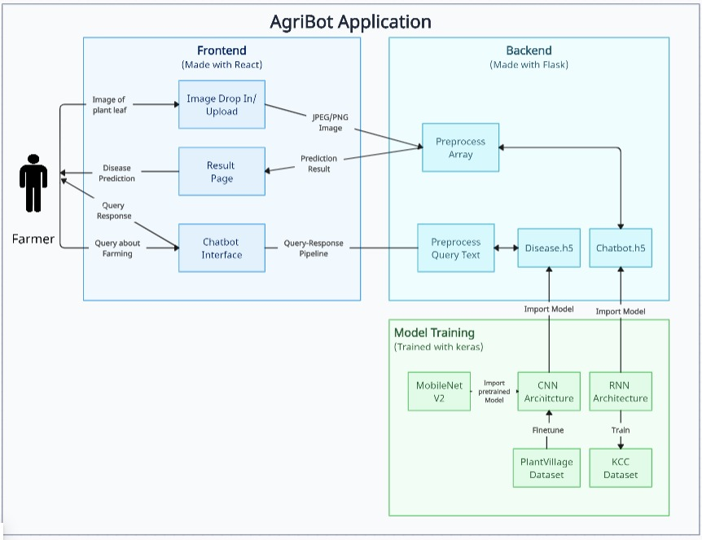

1. **Experimental Investigation**

During the development of this project, several experimental investigations and analyses has be conducted to enhance the solution's

**1. Chatbot Accuracy and Response Time:**

Evaluate the accuracy and response time of the AI chatbot by collecting a diverse dataset of farmer queries and corresponding expected responses. Measure the accuracy of the chatbot's generated responses compared to the expected responses. Analyze response time to ensure that the chatbot provides prompt replies to farmers' queries.

**2. Chatbot User Satisfaction Survey:**

Conduct a user satisfaction survey or feedback collection mechanism to gather farmers' opinions and feedback on the chatbot's performance. Assess user satisfaction, ease of use, and effectiveness of the chatbot in addressing their queries and providing relevant information

**3. Chatbot NLP Performance:**

Analyze the chatbot's natural language processing (NLP) capabilities by evaluating its understanding and interpretation of various query types, including questions, statements, and requests for specific information. Assess the chatbot's ability to extract relevant information and generate appropriate responses.

**4. Crop Disease Classification Accuracy:**

Measure the accuracy of the crop disease classification model by using a labeled dataset of crop disease images. Compare the predicted disease classifications with the ground truth labels to evaluate the model's accuracy in identifying different types of crop diseases.

**5. Weather API Integration:**

Evaluate the performance and reliability of the weather API integration by comparing the fetched weather data with external sources or official weather reports. Ensure that the API consistently provides accurate and up-to-date weather information for the targeted geographical regions.

**6. Scalability and Performance Testing:**

Perform scalability and performance tests to assess the system's capability to handle a large number of concurrent users and requests. Measure response times under varying loads and identify any potential bottlenecks or performance issues that need to be addressed.

**7. Error Handling and Robustness Testing:**

Test the system's robustness by simulating different error scenarios and edge cases. Investigate how the system handles unexpected inputs, errors, and exceptions. Evaluate the error handling mechanisms to ensure proper error reporting and graceful degradation of the system.

**8. Usability Testing:**

Conduct usability testing with a group of farmers or end users to assess the system's overall user experience, interface intuitiveness, and ease of navigation. Gather feedback on the UI/UX design, identify any usability issues, and make necessary improvements based on user suggestions.

By performing these experimental investigations and analyses, valuable insights can be gained to optimize the performance, accuracy, and user satisfaction of the chatbot and crop disease classification system. The findings can guide improvements, fine-tuning of models, and overall enhancements to deliver a more effective solution for farmers.

**4.Observations**

**AI chatbot**

The performance of the AI chatbot and crop disease classification system is evaluated using various metrics. For the chatbot, metrics such as accuracy, response time are measured. A comprehensive dataset of farmer queries and corresponding responses is collected for evaluation purposes.

The model architecture consists of an embedding layer, a SimpleRNN layer, and a dense layer with a softmax activation function. The model is compiled using the Adam optimizer and categorical cross-entropy loss function. The training data for the model is prepared by preprocessing and tokenizing the input sequences. The model is trained on this preprocessed data to understand and generate appropriate responses to farmers' queries

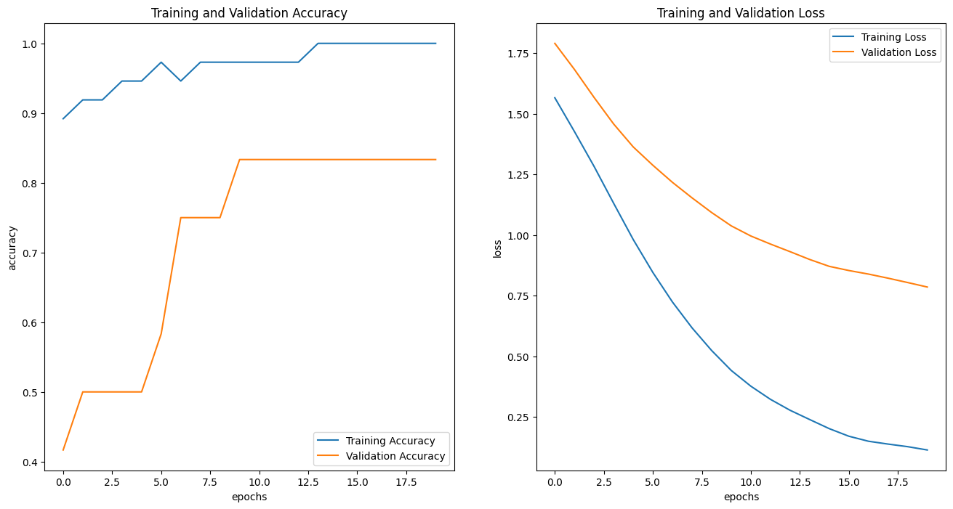

**Crop disease:**

The crop disease classification system's accuracy and precision metrics are evaluated using a separate dataset of labeled images. The results demonstrate the effectiveness and reliability of the developed system in providing accurate responses and identifying crop diseases.

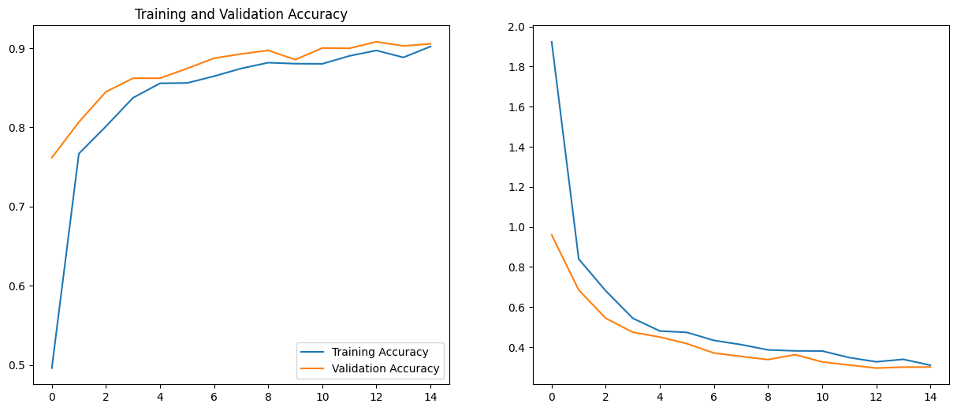

1. **Application and drawbacks**

The project has several applications that can benefit farmers and the agricultural sector. Some of the key applications include:

* Farmers' Assistance and Guidance: The AI chatbot can serve as a virtual assistant, providing farmers with instant access to agricultural information, best practices, and expert guidance. Farmers can obtain answers to their queries on various topics such as crop cultivation techniques, pest control measures, fertilizer recommendations, and market prices.
* Crop Disease Detection and Management: The crop disease classification system integrated into the project helps farmers identify and manage crop diseases effectively. By uploading images of affected crops, farmers can receive accurate disease classification results, enabling timely intervention and treatment. This can prevent the spread of diseases, minimize crop losses, and optimize yield.
* Weather Monitoring and Planning: The project's integration with a weather API allows farmers to receive real-time weather updates. Farmers can access information about temperature, rainfall, humidity, and other relevant weather parameters. This helps them plan their farming activities, irrigation schedules, and make informed decisions related to crop planting, harvesting, and protection.

**Advantages of the Project:**

* Accessible Information for Farmers: The AI chatbot provides farmers with instant access to agricultural information and expert guidance, addressing their queries and concerns promptly.
* Efficient Crop Disease Identification: The crop disease classification system assists farmers in accurately identifying crop diseases based on uploaded images, enabling timely intervention and treatment.
* Real-Time Weather Updates: By integrating the weather API, the project provides farmers with up-to-date weather information, allowing them to make informed decisions regarding crop cultivation and protection.
* User-Friendly Interface: The React-based user interface offers a visually appealing and intuitive experience, allowing farmers to interact with the chatbot easily and upload images for crop disease classification.

**Drawbacks of the Project:**

* Dependency on Internet Connectivity: The project heavily relies on a stable internet connection to access the weather API, retrieve information, and provide real-time responses. Farmers in remote areas with limited internet connectivity may face challenges in accessing the system.
* Limited Domain Expertise: The AI chatbot's effectiveness depends on the quality of the training data and the expertise of the developers in addressing farmers' queries. It may not possess the depth of knowledge that human experts in the agricultural domain possess
* Accuracy Limitations: While the crop disease classification system is trained on a reliable dataset, there may still be limitations in accurately identifying rare or new diseases or distinguishing between similar symptoms. Human intervention and expert opinions may still be required for accurate diagnosis in complex cases.
* Language Understanding Challenges: The chatbot's performance in understanding complex or nuanced queries, regional variations, or slang may be limited. The chatbot's responses might not always capture the full context or accurately address farmers' concerns.

1. **Conclusion**

In conclusion, this paper presents a project that integrates an AI chatbot and crop disease classification system for farmers. The chatbot, trained on an RNN model, enables farmers to obtain prompt and accurate answers to their queries. The crop disease classification system, based on the MobileNetV2 architecture, assists farmers in identifying crop diseases efficiently

1. **FUTURE SCOPE**

The project has several future scopes for further enhancement and expansion. Some of the potential future scopes for the project include:

* Advanced Natural Language Processing (NLP) Techniques: Incorporating more advanced NLP techniques like sentiment analysis, entity recognition, and context understanding can improve the chatbot's ability to comprehend and respond to complex queries more accurately. This can enhance the overall user experience and provide more insightful and personalized responses.
* Integration of Voice-based Interaction: Integrating voice-based interaction capabilities into the chatbot can provide farmers with the convenience of using voice commands or speech recognition for query submission and receiving responses. This can be especially beneficial for farmers who may have limited literacy or prefer voice-based interactions.
* Integration with IoT and Sensor Data: Incorporating data from IoT devices and sensors, such as soil moisture sensors, weather stations, and crop health monitoring systems, can provide real-time data inputs to the project. This integration can enable more accurate decision-making, predictive analytics, and proactive alerts for farmers regarding irrigation, fertilization, and crop health management

**REFERENCES**

* [React](https://react.dev/)
* [Quickstart — Flask Documentation (3.0.x) (palletsprojects.com)](https://flask.palletsprojects.com/en/3.0.x/quickstart/)

**APPENDIX I**

Code: [Rahulrayudu/farmapp (github.com)](https://github.com/Rahulrayudu/farmapp)

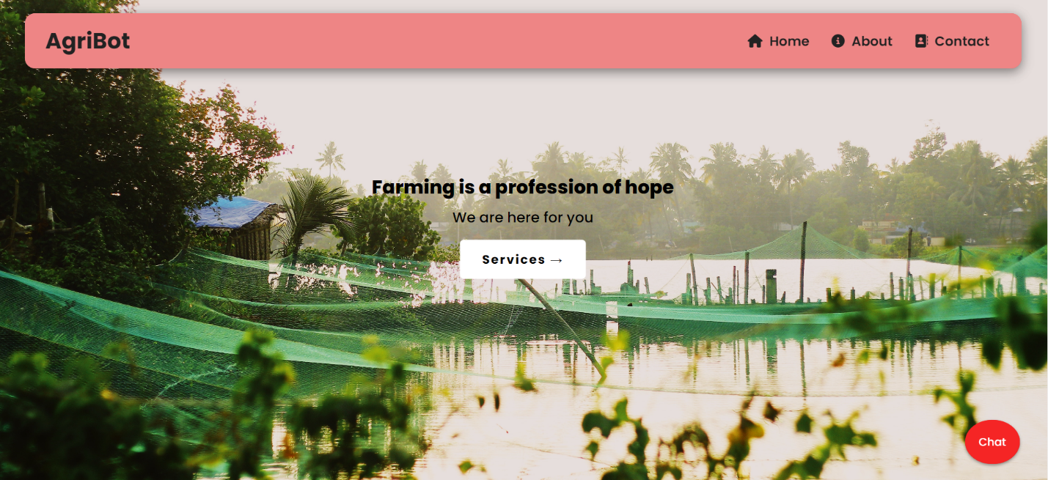

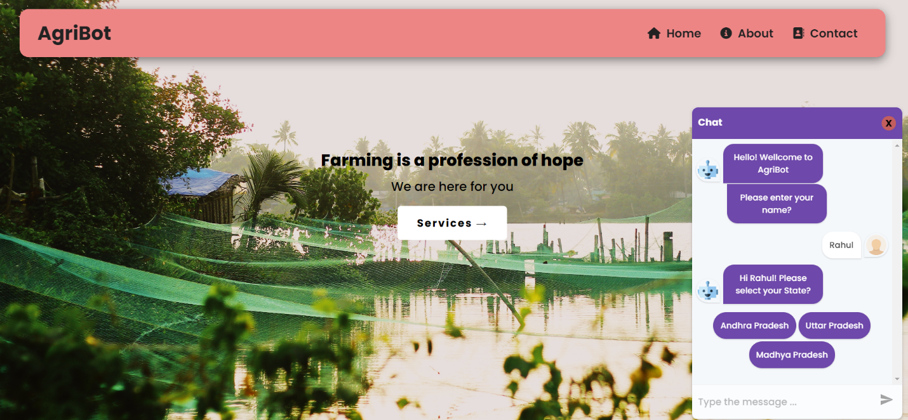

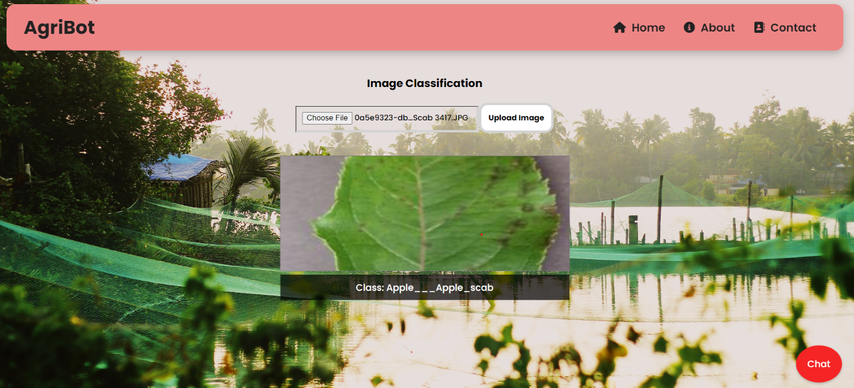

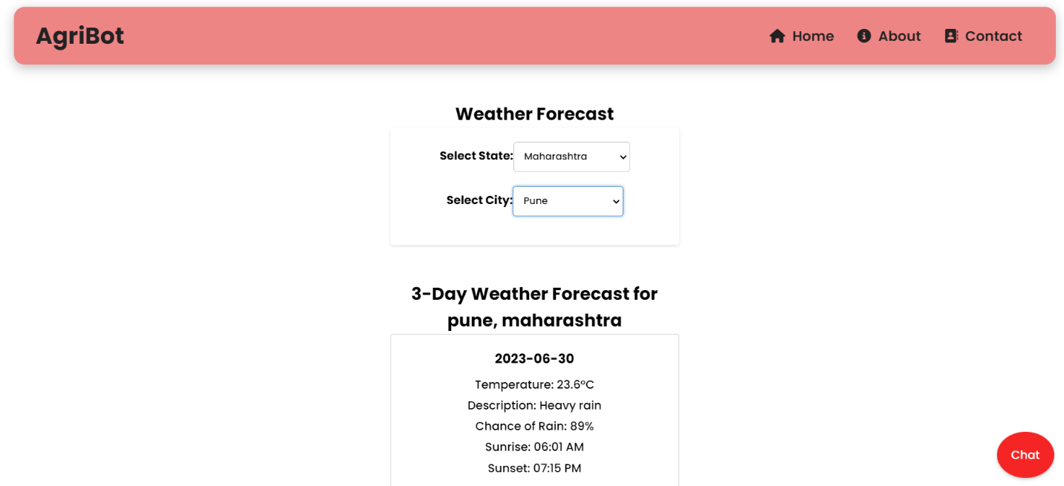

**GOOGLE CLOUD**

<https://www.cloudskillsboost.google/public_profiles/ae5ef503-2948-4256-b295-73723b423352>

